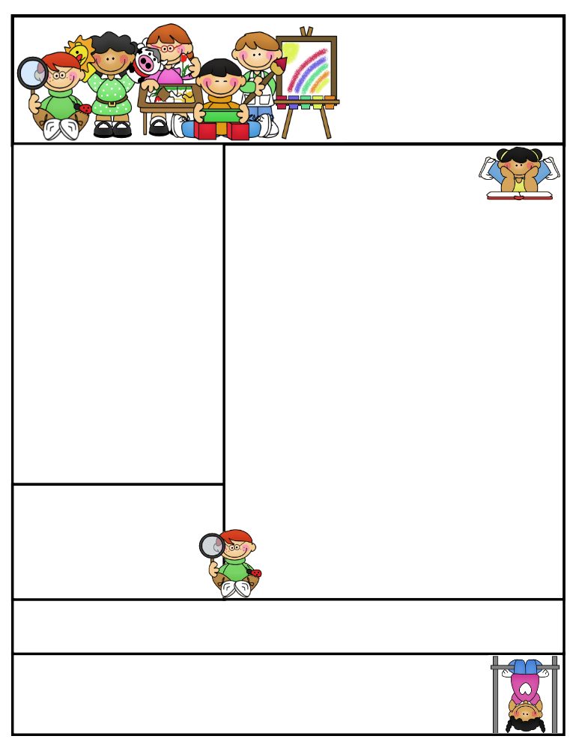
What we are working on…

- The Kindergarten Halloween party will be on Tuesday, October 31st at 9:30am. We are able to dress up in costumes, so please pack your child’s costume in their backpack and they will get changed here. People providing treats are listed below. If you would also like to donate, I do need plates and napkins. Thanks!
Gage Grone (Samantha) Juice Boxes
Breanna Roberts (Mandy) Cookies
Nina Hoyt (Michelle) Cupcakes
- Reading: We’ve been reviewing letters A, C, M, N, P, R, S, and T. We continue to practice our word wall words: a, go, I, my, the, & to. Please keep working on these at home.
- Writing: We are learning how to be 6 star writers:
- Put the date at the top of my paper
- Use neat writing
- Start my sentence with a capital letter
- Use finger spaces between my words
- Use punctuation at the end of my sentence
- Does my sentence make sense?
- Math: Writing numbers 0-20, counting as high as we can, and # recognition
Important Dates:
October 31st - Early Dismissal - Students dismissed at 1:00pm
November 22nd-24th – Thanksgiving Recess – No School
December 14th - Christmas Program @ 7pm
December 15th – Staff Professional Development – No School December 22nd – January 2nd - Christmas Vacation – No School
January 3rd – Back to School
January 12th – Early Dismissal at 1:00
January 19th - Half Day for students – Dismissed at 11:45

Mrs. Keesler
akeesler@browncityschools.org
mrskeesler.weebly.com (CHECK IT OUT! )
Mrs. Keesler’s
Kindergarten News
October 27th, 2017
Literacy Tip: Practice those sight words: go, a, I, my, the, to
Math Tip: Keep writing and identifying numbers 0-20. Practice counting to 100!

Please continue saving your box tops and bring them into school

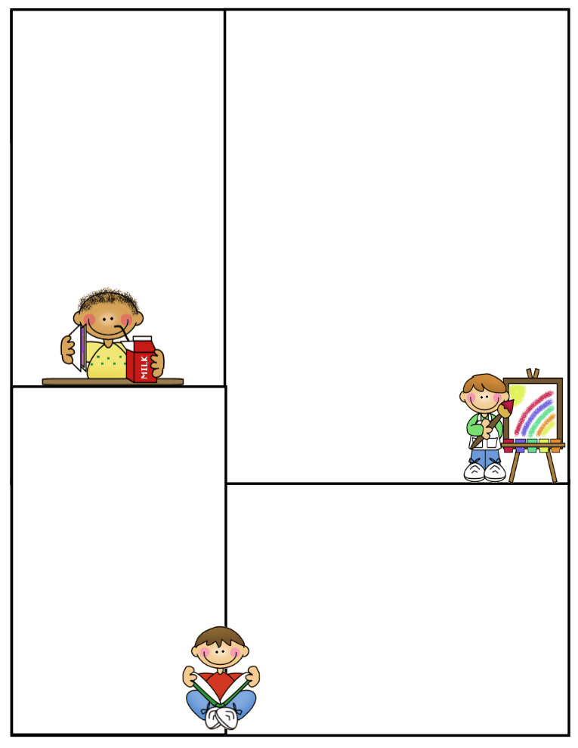
Other Information Here
Student of the Week
Lunch Menu
Monday:
Tuesday:
Wednesday:
Thursday:
Friday:
What We’re Learning
Reading:

Math:

Writing:

Science:

Social Studies:

Newsletter Template
Customize the newsletter template to meet your classroom needs. Click inside a box to type your information. Change the boxes to whatever you’d like to include!

Visit my blog for more freebies and lesson ideas:
http://firstgradebrain.blogspot.com

Visit my TeachersPayTeachers store for more products:
http://www.teacherspayteachers.com/Store/Mrs-Magee/Products

