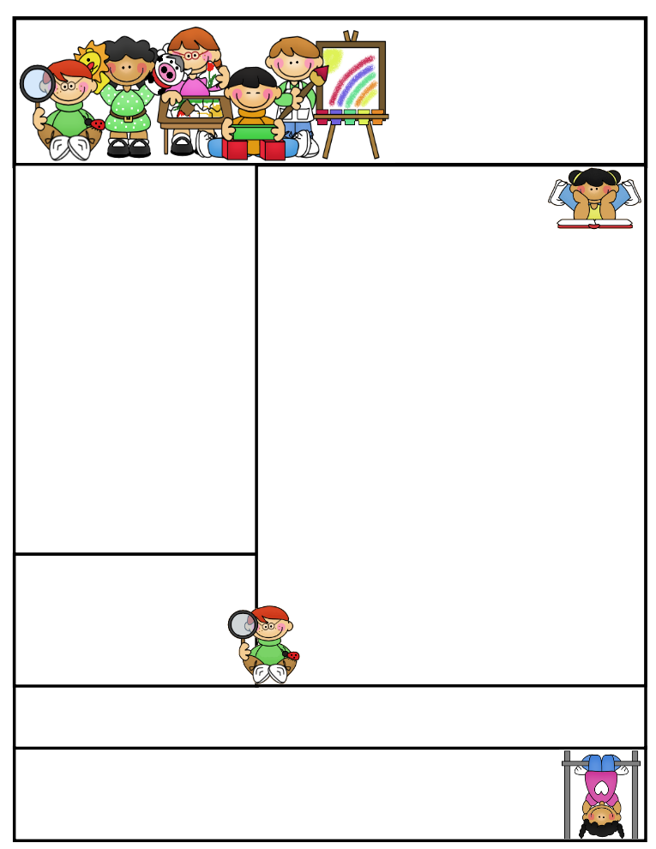

**Important Dates:**

**October 31st -** Early Dismissal - Students dismissed at 1:00pm

**November 22nd-24th** – Thanksgiving Recess – No School

**December 14th -**  Christmas Program @ 7pm

**December 15th –** Staff Professional Development – No School **December 22nd – January 2nd -**  Christmas Vacation – No School

**January 3rd –** Back to School

**January 12th –** Early Dismissal at 1:00

**January 19th -** Half Day for students – Dismissed at 11:45

Mrs. Keesler

[akeesler@](mailto:akeesler@)browncityschools.org

mrskeesler.weebly.com (CHECK IT OUT! ☺ )

Mrs. Keesler’s  
Kindergarten News

October 20th, 2017

Literacy Tip: Practice those sight words: go, a, I, my, the

Math Tip: Keep writing and identifying numbers 0-20. Practice counting to 100!

Please continue saving your box tops and bring them into school ☺

**Classroom News**

* It’s starting to get cooler!! **Please make sure your child has outside clothes for that chilly morning recess.**
* Do not forget your gym shoes on Wednesday and library books on Monday.
* Thank you for all of the Grandparent day goodies! We could not have done it without all of you! Thanks so much!
* **Reading Incentive –** We are doing a great job turning in those reading sheets! Keep them coming! A reading sheet a month allows your child to join in on the reading incentive assembly/activity. They really enjoy these activities and only get to participate if they turn in a reading sheet that month.

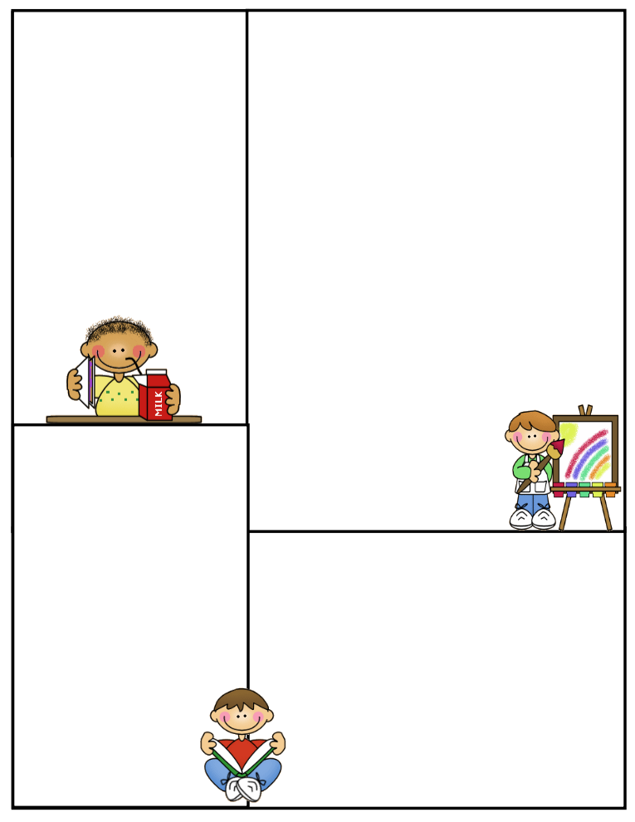

Other Information Here

Student of the Week

Lunch Menu

Monday:

Tuesday:

Wednesday:

Thursday:

Friday:

What We’re Learning

Reading:

Math:

Writing:

Science:

Social Studies:

**Newsletter Template**

Customize the newsletter template to meet your classroom needs. Click inside a box to type your information. Change the boxes to whatever you’d like to include!

Visit my blog for more freebies and lesson ideas:

<http://firstgradebrain.blogspot.com>

Visit my TeachersPayTeachers store for more products:

<http://www.teacherspayteachers.com/Store/Mrs-Magee/Products>