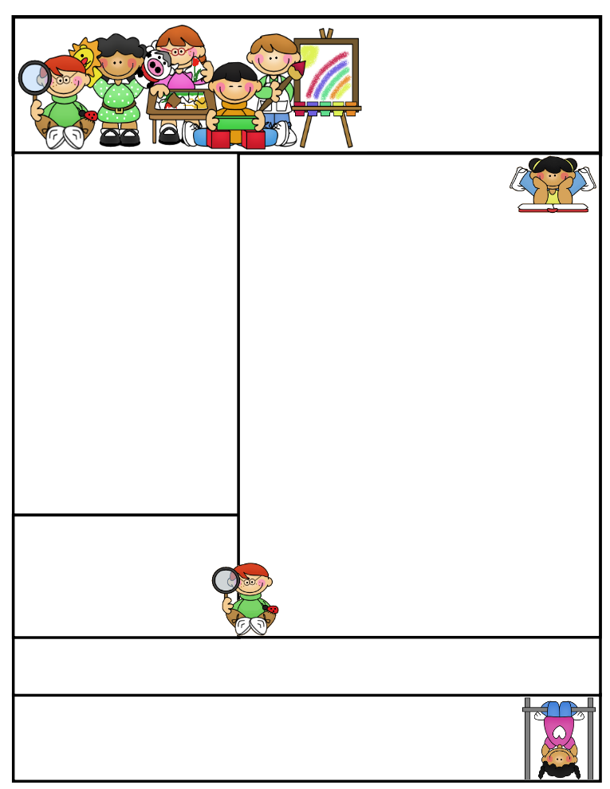

**Important Dates:**

**October 18th -** Half Day – Students dismissed at 11:45  
**​**Parent/Teacher Conferences - 12:30 - 3:00

**October 19th -**Parent/Teacher Conferences - 4:00 - 8:30 **​**

**October 20th-** Grandparents Day! Elementary Gym - 9:30am - 11:00 -Half Day - Students dismissed at 11:45

**October 31st -** Early Dismissal - Students dismissed at 1:00pm

Mrs. Keesler

[akeesler@](mailto:akeesler@)browncityschools.org

mrskeesler.weebly.com (CHECK IT OUT! ☺ )

Mrs. Keesler’s  
Kindergarten News

October 13th, 2017

Literacy Tip: Read Read Read! :

Math Tip: Keep writing and identifying numbers 0-20. Practice counting to 100!

Parent/Teacher Conferences:

October 18th – 12:30 – 3

October 19th – 4 – 8:30

**Classroom News**

* **Please send in or email a picture of your child with their grandparents for a Grandparent Day project. The picture will be returned ASAP.**
* Please continue saving your box tops and bring them into school ☺
* It’s starting to get cooler!! **Please make sure your child has outside clothes for that chilly morning recess.**
* Don’t forget your gym shoes on Tuesday and library books on Wednesday.
* Halloween is coming up! We will be dressing up school-wide this year. More info to come. ☺

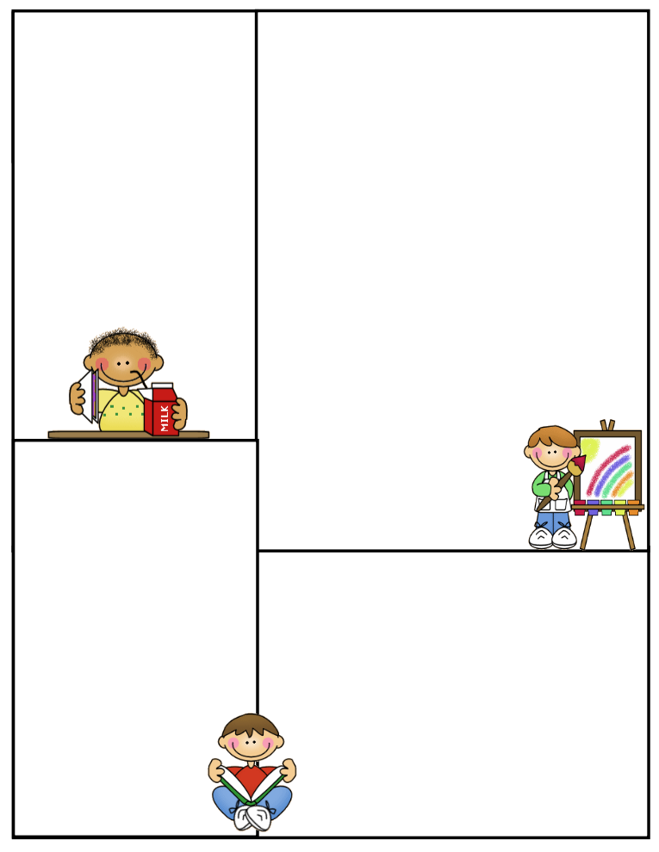

Other Information Here

Student of the Week

Lunch Menu

Monday:

Tuesday:

Wednesday:

Thursday:

Friday:

What We’re Learning

Reading:

Math:

Writing:

Science:

Social Studies:

**Newsletter Template**

Customize the newsletter template to meet your classroom needs. Click inside a box to type your information. Change the boxes to whatever you’d like to include!

Visit my blog for more freebies and lesson ideas:

<http://firstgradebrain.blogspot.com>

Visit my TeachersPayTeachers store for more products:

<http://www.teacherspayteachers.com/Store/Mrs-Magee/Products>