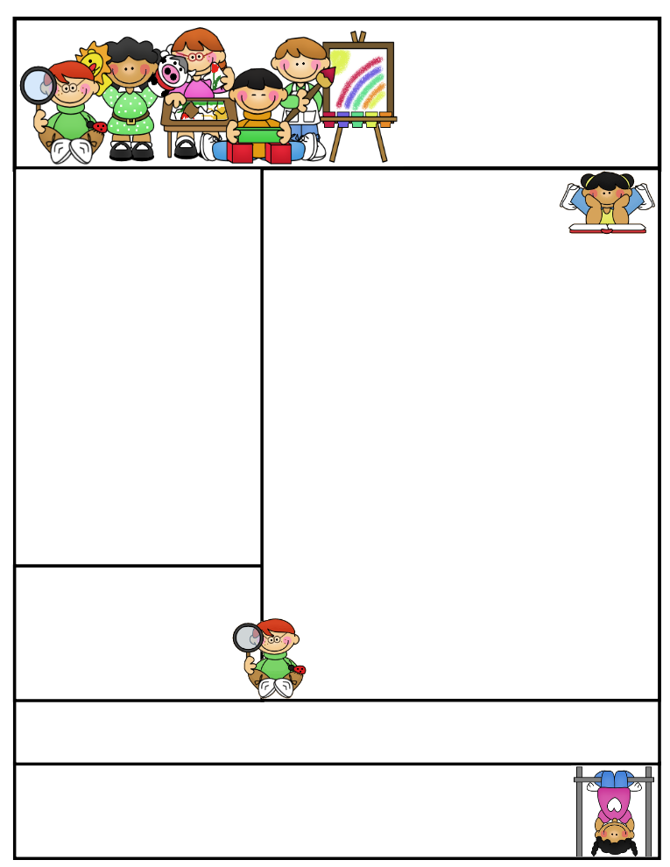

**Important Dates:**

**October 11th –** Fundraiser Sale ends

**October 18th -** Half Day - Students dismissed at 11:45  
**​** Parent/Teacher Conferences - 12:30 - 3:00  
**October 19th -**Parent/Teacher Conferences - 4:00 - 8:30 **​October 20th-** Grandparents Day! Elementary Gym - 9:30am - 11:00 -Half Day - Students dismissed at 11:45

**October 31st -** Early Dismissal - Students dismissed at 1:00pm

Mrs. Keesler

[akeesler@browncityschools.org](mailto:akeesler@browncityschools.org)

mrskeesler.weebly.com (CHECK IT OUT! ☺ )

Mrs. Keesler’s  
Kindergarten News

October 6th, 2017

Literacy Tip: Read Read Read! :

Math Tip: Keep writing and identifying numbers 0-20. Practice counting to 100!

Parent/Teacher Conferences:

October 18th – 12:30 – 3

October 19th – 4 – 8:30

**Classroom News**

* **Please send in a picture of your child with their grandparents for a Grandparent Day project. The picture will be returned ASAP.**
* Please continue saving your box tops and bring them into school ☺
* Keep reading and filling out your reading incentive sheets! Students are already earning prizes!!!☺
* To kick off fire safety week, the Brown City Fire Hall is holding a fire safety open house this Saturday, October 7th from 11:00 am – 2:00 pm. Everyone is welcome! I hope you can make it.