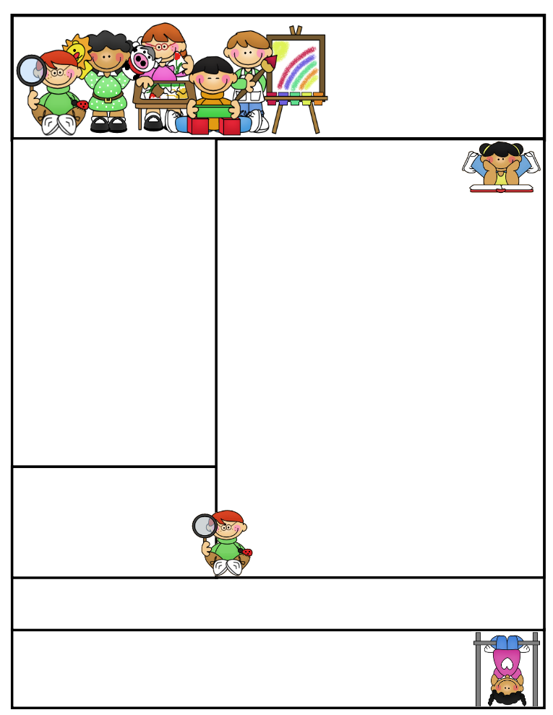

**Important Dates**

**September 27th** – Fundraiser kickoff

**October 4th –** PJ’s for count day- wear your pajamas to school. ☺

**October 18th** - Half Day - Students dismissed at 11:45  
​                        Parent/Teacher Conferences - 12:30 - 3:00  
​

**October 19th** - Parent/Teacher Conferences - 4:00 - 8:30  
​

**October 20th** - Grandparents Day! Elementary Gym - 9:30am - 11:00  
​                        Half Day - Students dismissed at 11:45

**October 31st** - Early Dismissal - Students dismissed at 1:00pm

**Classroom News**

* Book orders are due Thursday, September 28

if you would like to order ☺

* Please keep saving and sending in your box tops. ☺

* The mornings have been a bit chilly, please send your child with appropriate outdoor clothing – layers are great!

* Homework will usually go home on Friday and due back by the following Friday. (I got ahead of myself and sent it early this week.) These lessons go along with what we are learning in class.

* The Brown City High School Varsity Cheerleaders would like to invite your child to participate in the K-6 cheer clinic. We will have one week of practice and then all students will perform during the first half of the **Junior Varsity** football game ***Thursday, October 5th. Please note the day/game change from previous years.*** More info coming soon!

**Weekly Schedule:**

Monday: Library, am & pm recess

Tuesday: Music & am & pm recess

Wednesday: Gym, am & pm recess

Thursday: Computers, am & pm recess

Friday: Am & pm recess

Don’t forget your library books and gym shoes.

Mrs.Keesler’s Contact Info:

[akeesler@browncityschools.org](mailto:akeesler@browncityschools.org)

mrskeesler.weebly.com

Mrs. Keesler’s  
Kindergarten News

September 22, 2017

**Literacy Tip**: Keep practicing letter recognition and letter sounds. Practice writing first names with an uppercase letter at the beginning and the rest lowercase.

**Math Tip**: Practice counting, colors, and shapes.

Reminder…

If you have not already, please sign up for REMIND to get classroom updates via text message.

TEXT: 367h3h TO: 81010

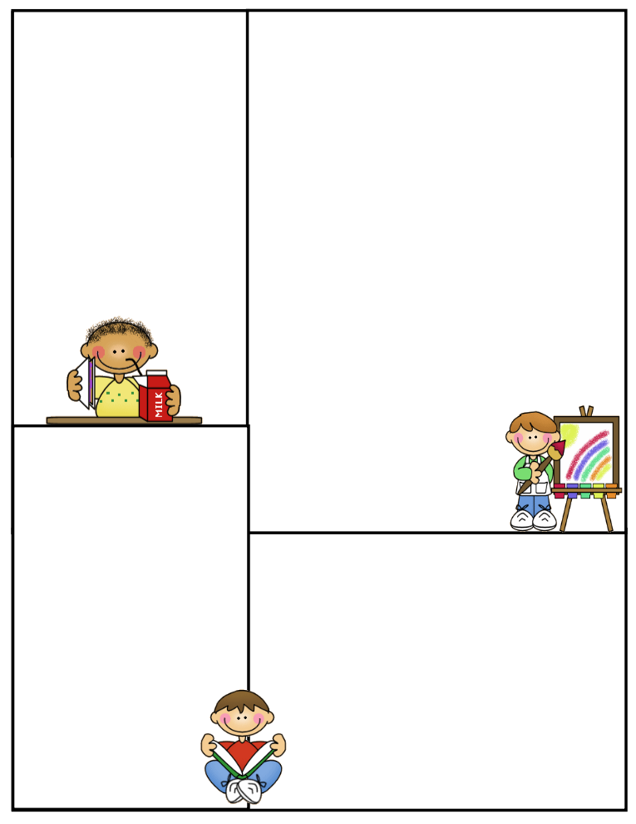

Other Information Here

Student of the Week

Lunch Menu

Monday:

Tuesday:

Wednesday:

Thursday:

Friday:

What We’re Learning

Reading:

Math:

Writing:

Science:

Social Studies: