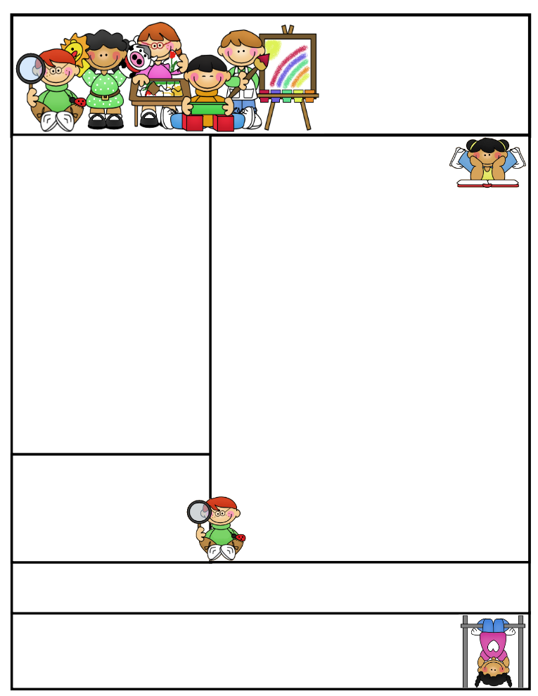

**Classroom News**

* Thursday, September 28 is the due date for ordering books through Scholastic. If you would like to order, please return by then.
* We are in need of classroom snacks. We have snack daily and do not have much to share with the class.
* Please keep saving and sending in your box tops. ☺
* The mornings have been a bit chilly, please send your child with appropriate outdoor clothing – layers are great!

**Weekly Schedule:**

Monday: Library, am & pm recess

Tuesday: Music & am & pm recess

Wednesday: Gym, am & pm recess

Thursday: Computers, am & pm recess

Friday: Am & pm recess

Don’t forget your library books and gym shoes.

Mrs. Keesler’s Contact Info:

[akeesler@browncityschools.org](mailto:akeesler@browncityschools.org)

mrskeesler.weebly.com

Mrs. Keesler’s  
Kindergarten News

September 15, 2017

**Literacy Tip**: Keep practicing letter recognition and letter sounds. Practice writing first names with an uppercase letter at the beginning and the rest lowercase.

**Math Tip**: Practice counting, colors, and shapes.

Reminder…

If you have not already, please sign up for REMIND to get classroom updates via text message.

**Important Dates**

**September 27th** – Fundraiser kickoff

**October 18th** - Half Day - Students dismissed at 11:45  
​   Parent/Teacher Conferences - 12:30 - 3:00  
​

**October 19th** - Parent/Teacher Conferences - 4:00 - 8:30  
​

**October 20th** - Grandparents Day! Elementary Gym - 9:30am - 11:00  
​ Half Day - Students dismissed at 11:45

**October 31st** - Early Dismissal - Students dismissed at 1:00pm

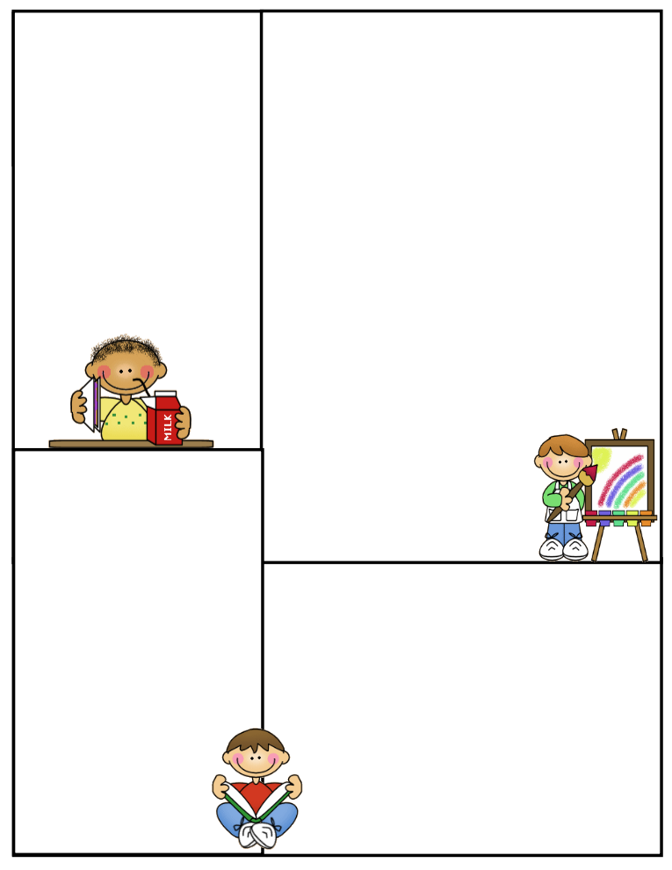

Other Information Here

Student of the Week

Lunch Menu

Monday:

Tuesday:

Wednesday:

Thursday:

Friday:

What We’re Learning

Reading:

Math:

Writing:

Science:

Social Studies: