

Contact Information

[akeesler@browncityschools.org](mailto:akeesler@browncityschools.org)

mrskeesler.weebly.com

**Updates:**

Please keep reading. Our reading incentive is in full swing. By June, you will need to turn in at least 5 reading sheets of 25 books each. The awards assembly is a big deal, so please help your child receive one by turning in his/her sheet.

Please keep sending in those box tops. They really do earn a large amount of money for our school. ☺

**Reminders:**

* Students go outside at least once a day. Please be sure they have coats, snow pants, boots, hats, and gloves for the cold winter days on the playground. You are welcome to leave an extra set of anything you have in their cubby.
* Also, please send in an extra pair of shoes (practice that shoe tying ☺) or slippers, so that students aren’t wearing their snow boots all day. Thanks!

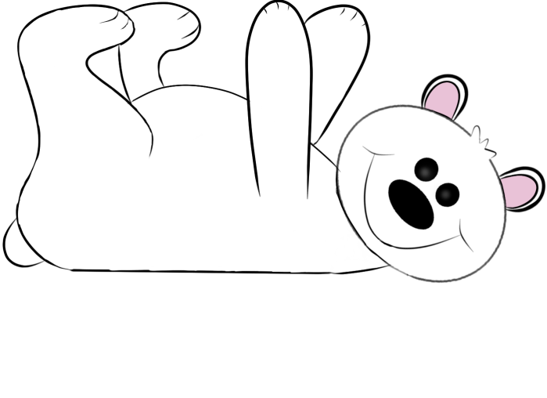

**Weekly Schedule:**

**Monday** – Library, am & pm recess

**Tuesday** – music, am & pm recess

**Wednesday** – Gym, a.m. recess & pm recess

**Thursday** – computers, am & pm recess

**Friday** – am & pm recess

***Don’t forget your gym shoes and library books***

**Important Dates:**

**Fri., Jan 12** – early dismissal – 1:00

**Fri., Jan. 19** – ½ day – 11:45

dismissal.

**Fri., Feb 16** – **Mon. Feb. 19 -** No School – Mid-Winter Break